Australian Design Rule Tyre Placard
All Passenger Cars manufactured from January 1972 onwards, Light Trucks Four Wheel Drive (4WD) vehicles manufactured from July 1990 have a vehicle tyre placard fitted. Ina number of cases some (4WD’s) have two fitment placards on the vehicle to cover two different types of tyre fitment:- Passenger and Light Truck.
These tyre fitment placards are cover under ADR24 up to the 31 December 2004 and is superceded on 1 January 2005 by (ADR 42/04) placard rule.
The vehicle tyre fitment placard is the governing aspect for ALL tyre fitments and must be checked to ascertain what variants are permissible under the placard. The following examples provide a guide as to what may be found on the Placard.
Please note: You should always check the proviso contained within the placard comments. As can be seen here in the example when the vehicle is operating at high speed the tyre inflation must be adjusted to maintain a safe working pressure to carry the load.

Passenger Diagram No.1
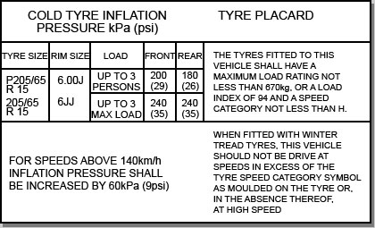

Passenger Diagram No.1
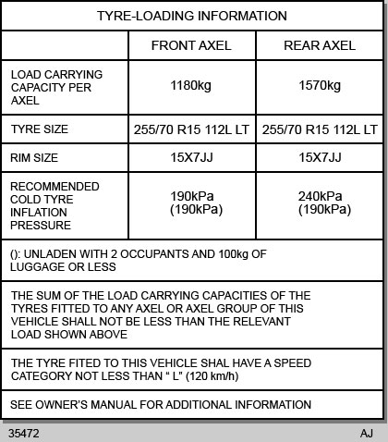
Diagram No.1 shows a passenger vehicle tyre placard that specifies a minimum Load Index 94 which mean 670kgs per tyre along with the governing speed category symbol of “H” (210km/h) which is permissible for this vehicles tyre fitment.
In diagram No.2 it shows a light truck tyre placard and specifies an “LT” tyre with a Load Index of 112 that means 1120kgs per tyre with a speed category symbol of not less than “L” (120km/h) for the vehicle.

Light Truck Diagram No.3
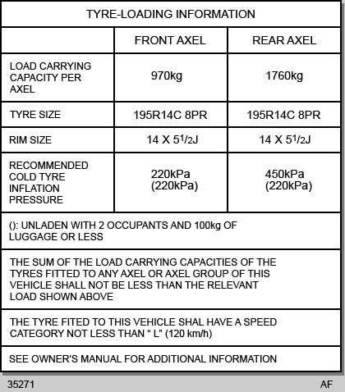
Diagram No. 3 depicts another light truck tyre with a “C” symbol after the rim size indicating a commercial tyre fitment with an 8 ply rating equal to a 106 Load Index capability of 950kgs per tyre. The label shows a speed symbol category of not less than “L” (120km/h) for the vehicle.We have presented a number of tyre placard examples from vehicle manufacturers and it should be noted that other vehicle manufacturers may vary the degree of tolerance in load Kgs and index for tyre fitment for their specific vehicle.A common example of where this may apply is the tyre fitment for a number of Commodore vehicles where a standard 205/60R 15 95 (690) H is fitted and the variance in load index 92H with a minimum load of 630 Kgs.Who initiates the Vehicle Tyre Placard Specifications – The vehicle manufacturer is the principal party that sets the original tyres fitment for a nominate vehicle this is done in consultation with the tyre supplier. The tyre manufacturer supplies a tyre to meet the specific requirements of the vehicle manufacture covering load and Speed Symbols.

